 | 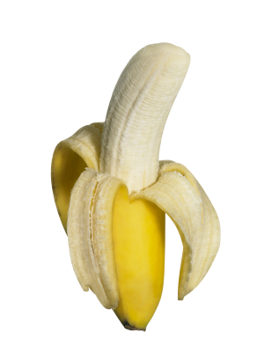 | Banane |  |  | 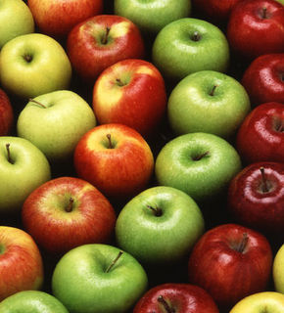 | Äpfel |  |  | 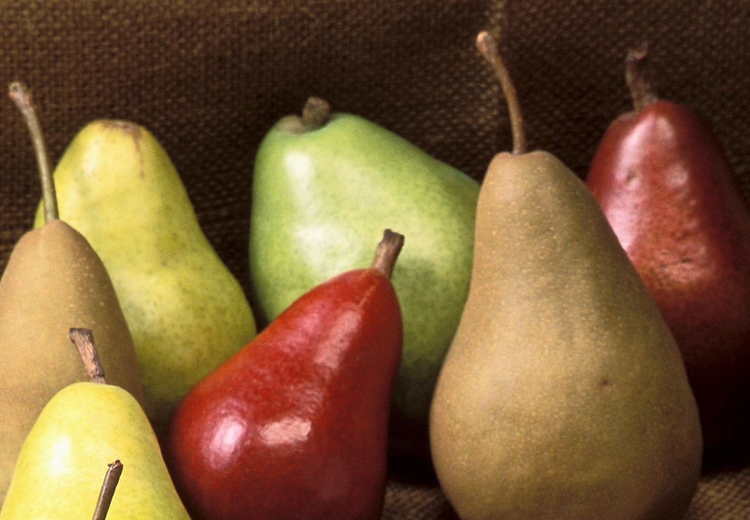 | Birnen
 | 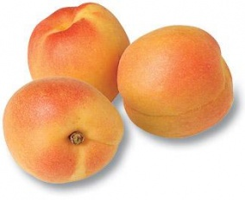 | Pfirsiche |  |  | 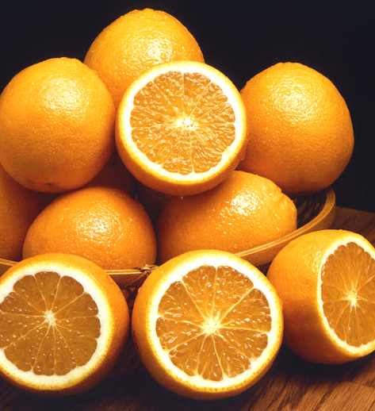 | Apfelsinen |  |  | 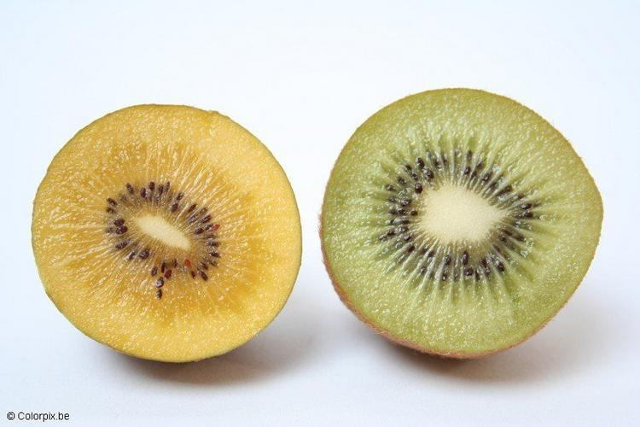 | Kiwi
 | 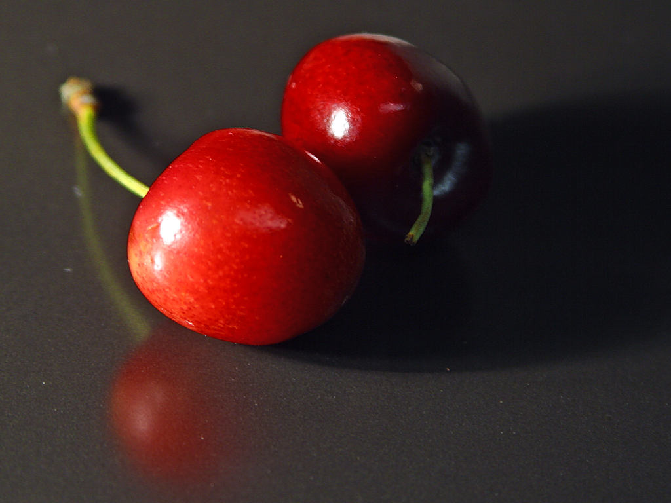 | Kirschen |  |  | 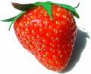 | Erdbeere |  |  | 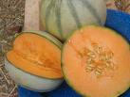 | Melone

 | 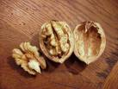 | Walnuss |  |  | 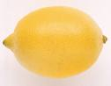 | Zitrone |  |  | 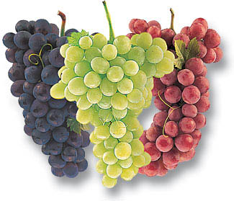 | Weintraube
 | 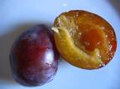 | Pflaume |  |  | 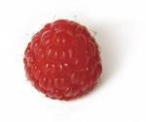 | Himbeere |  |  | 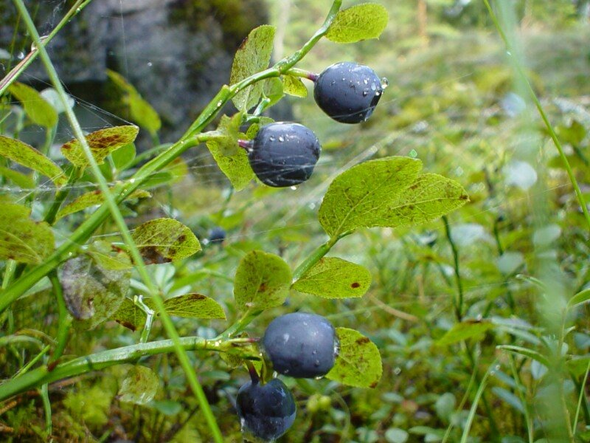 | Blaubeere
 | 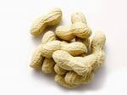 | Erdnüsse |  |  | 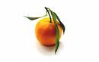 | Clementine |  |  | 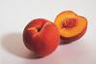 | Pfirsich

 | 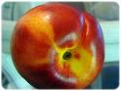 | Nektarine |  |  | 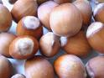 | Haselnüsse |  |  | 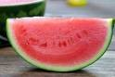 | Wassermelone
 | 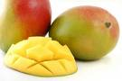 | Mango |  |  | 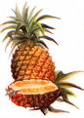 | Ananas |  |  | 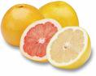 | Pampelmuse
 | 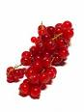 | rote Johannisbeeren

